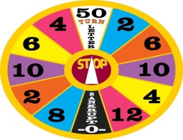

WHEEL SPIN
HELP SUPPORT THE L.A. XMAS HAMPERS
CLOSING DATE: NOVEMBER 18, 2018 at the
JAM SESSION/MEATDRAW

BAKE SALE
HELP SUPPORT THE LA XMAS HAMPERS
NOVEMBER 23-25 (Grey Cup Weekend)

